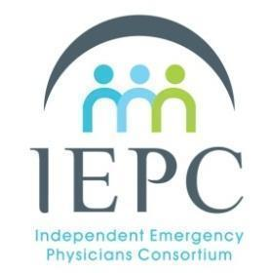
IEPC Meeting
August 26, 2024
9:00 am - 11:00 am PT
Meeting to be held by Zoom Video Conference
Agenda & Minutes
All people present at this meeting must have a signed IEPC Non-Disclosure Agreement (NDA). All content and discussions in this meeting are held to confidentiality in NDA.

Attendees:
Speaker: Dr. Leon Adelman
Admin:

- Introductions
- Speaker sessions
  - Dr. Leon Adelman - Should Physicians Unionize?
- Presidential Report
- Financial Report and IEPC Operations
- Roundtable

Next Meeting
September 23, 2024 9:00 AM PT

