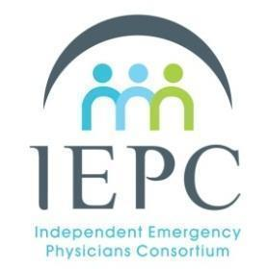
IEPC Meeting
October 28, 2024
9:00 am - 11:00 am PT
Meeting to be held by Zoom Video Conference
Agenda & Minutes
All people present at this meeting must have a signed IEPC Non-Disclosure Agreement (NDA). All content and discussions in this meeting are held to confidentiality in NDA.

Attendees: Roneet Lev, Sameer Mistry, Andrew Fenton, Robert Chavez, Brian Potts, Clayton Whiting, Kavitha Weaver, Michelle Kalinski, John Ellison
Speaker: Stephen Freedman and Mark Savoie
Admin: Abby Kojsza

- Introductions
- Speaker sessions
  - Stephen Freedman and Mark Savoie of The Doctors Company - Malpractice Updates
  - Presentation Debrief with Dr. Richard Benedon
- Roundtable

Next Meeting
November 25th, 2024 9:00 AM PT

